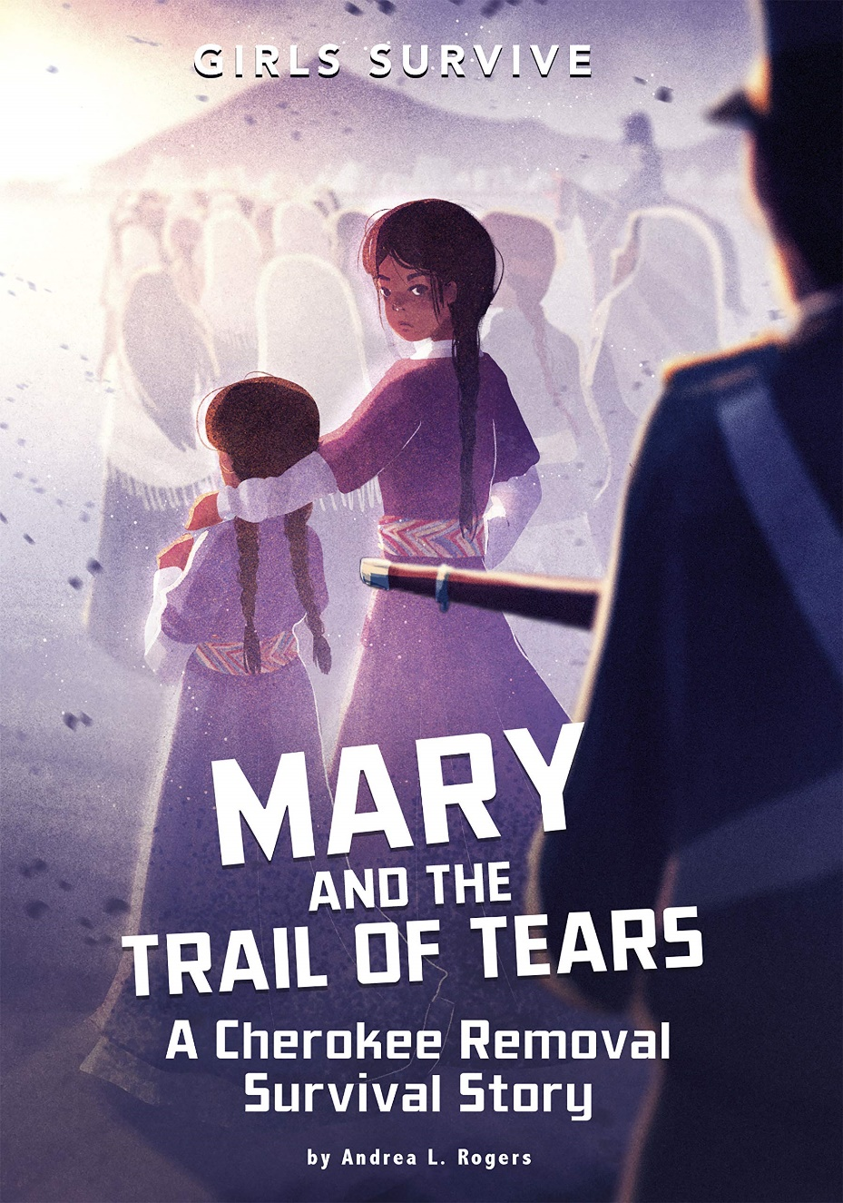

**Mary and the Trail of Tears: A Cherokee Removal Survival Story** by Andrea L. Rogers

Twelve-year-old Mary and her Cherokee family are forced out of their home in Georgia by U.S. soldiers in May 1838. From the beginning of the forced move, Mary and her family are separated from her father. Facing horrors such as internment, violence, disease, and harsh weather, Mary perseveres and helps keep her family and friends together until they can reach the new Cherokee nation in Indian Territory. Featuring nonfiction support material, a glossary, and reader response questions, this Girls Survive story explores the tragedy of forced removals following the Indian Removal Act of 1830.

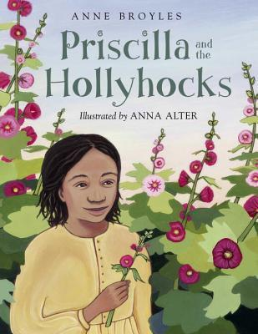

**Priscilla and the Hollyhocks** by Anne Broyles, Anna Alter

Priscilla is only four years old when her mother is sold to another master. All Priscilla has to remember her mother by are the hollyhocks she planted by the cow pond. At age ten, Priscilla is sold to a Cherokee family and continues her life as a slave. She keeps hope for a better life alive by planting hollyhocks wherever she goes. At last, her forced march along the Trail of Tears brings a chance encounter that leads to her freedom.

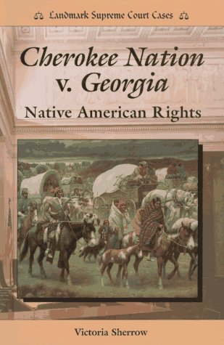

**Cherokee Nation V. Georgia: Native American Rights** (Landmark Supreme Court Cases) by Victoria Sherrow

Discusses the cases brought by the Cherokee Nation against the state of Georgia, beginning in the 1830s, to protect the rights of the Cherokee living there

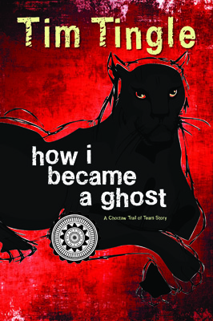

**How I Became a Ghost** by Tim Tingle

Told in the words of Isaac, a Choctaw boy who does not survive the Trail of Tears, HOW I BECAME A GHOST is a tale of innocence and resilience in the face of tragedy. From the book's opening line, "Maybe you have never read a book written by a ghost before," the reader is put on notice that this is no normal book. Isaac leads a remarkable foursome of Choctaw comrades: a tough-minded teenage girl, a shape-shifting panther boy, a lovable five-year-old ghost who only wants her mom and dad to be happy, and Isaac s talking dog, Jumper.



**Lady Unveiled: Catharine Greene Miller** by Pamela Bauer Mueller

During a compelling life that took her from Rhode Island to Cumberland Island, GA, Kitty Greene broke the bondage of tradition. Married to the legendary General Nathanael Greene, this controversial, independent woman charmed and inspired living icons: Benjamin Franklin, George and Martha Washington, Henry and Lucy Knox, “Mad” Anthony Wayne and others through the tumultuous times surrounding the Revolutionary War.

Faced with challenges that would unnerve a less resourceful woman, Kitty made a name for herself. A churning mass of contradictions—beautiful, elegant and intelligent—she also made meaningful contributions to ongoing political discussions led by her husband and his friends. Drawn to the company of men at social gatherings, Kitty was slandered for bending the rules of propriety. Yet this enabled her to be instrumental in the development of the age’s most remarkable invention, the cotton gin. Because of the limitations of her era, she took no credit, giving Eli Whitney all rights of invention. Founding Mother Catharine Greene Miller's irrepressible spirit and influence altered the history of America.



**The Underground Railroad** By Colson Whitehead

After Cora, a pre-Civil War Georgia slave, escapes with another slave, Caesar, they seek the help of the Underground Railroad as they flee from state to state and try to evade a slave catcher, Ridgeway, who is determined to return them to the South.

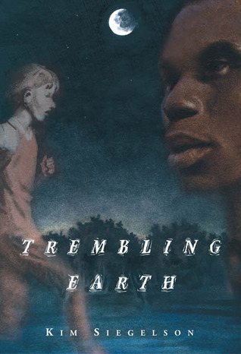

**Trembling earth** by Siegelson, Kim L.

In 1864, two boys, one enslaved and running toward freedom and one hoping to collect the reward for capturing him, make their way through Georgia's Okefenokee Swamp, relying on knowledge the white boy's father, disabled by the war, had passed on to him in happier times.

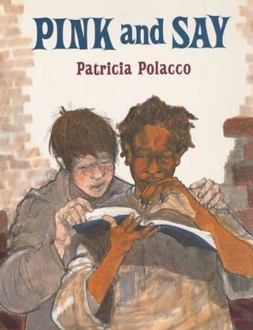

**Pink and Say** by Patricia Polacco

This story, about how a young black soldier rescues a white soldier, opens young readers' eyes to the injustices of slavery and the senselessness of war. Highly charged emotionally, this masterful retelling of a true story is seen through the white soldier's eyes.

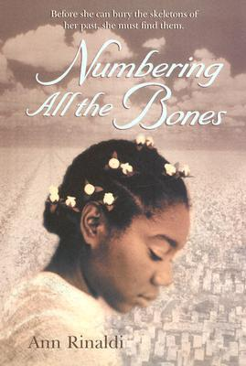

**Numbering All the Bones** by Ann Rinaldi

It is 1864. The Civil War is at an end, but for thirteen-year-old Eulinda, it is the most difficult time of her life. Her younger brother, falsely accused of stealing, has been sold. Then her older brother Neddy runs away. And Eulinda is left alone in a household headed by a cruel mistress -- and a master who will not acknowledge that Eulinda is his daughter. Her mettle is additionally tested when she realizes her brother Neddy might be buried in the now-closed Andersonville Prison where soldiers were kept in torturous conditions. With the help of Clara Barton, the eventual founder of the Red Cross, Eulinda must find a way to let go of the skeletons from her past.

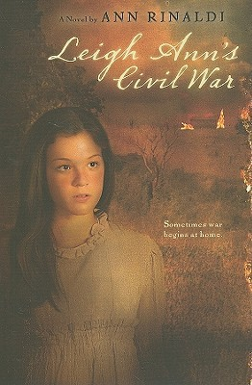

**Leigh Ann's Civil War** by Ann Rinaldi

Leigh Ann Conners is spunky and determined. Although she often finds herself in trouble, she loves her two older brothers dearly and would do anything to make them proud.

When the Yankees arrive in Roswell, Georgia, Leigh Ann places a French flag upon the family’s mill. She hopes the Yankees will then spare the mill from destruction, but her actions have disastrous results. Sent north with the women and children who worked in the mill—all branded traitors for making fabric for Confederate uniforms—Leigh Ann embarks on a journey that requires her to find her own inner strength. Only then will she be able to rise above the war raging around her.

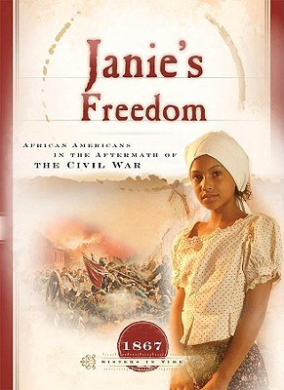

**Janie's freedom: African Americans in the aftermath of the Civil War** by Callie Smith Grant.

Time 1867 Eleven-year-old Janie finds herself in a quandary. The War Between the States is now over, and Miss Laura, widowed mistress of Rubyhill Plantation, has told Rubyhill's former slaves they're welcome to stay or free to leave. But for Janie, where should she go? There are still dangers in the South, and so many unknowns in the North-and moving may eliminate any chance of ever finding her mother. Using actual historical events to tell the poignant story of a newly-liberated young slave girl, Janie's Freedom is an excellent read for eight- to twelve-year-old girls, teaching American history and the Christian faith at the same time.

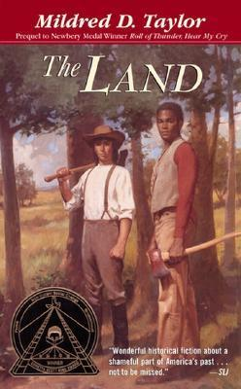

**The Land** by Mildred D. Taylor

The son of a prosperous landowner and a former slave, Paul-Edward Logan is unlike any other boy he knows. His white father has acknowledged him and raised him openly—something unusual in post-Civil War Georgia. But as he grows into a man he learns that life for someone like him is not easy. Black people distrust him because he looks white. White people discriminate against him when they learn of his black heritage. Even within his own family he faces betrayal and degradation. So at the age of fourteen, he sets out toward the only dream he has ever had: to find land every bit as good as his father's, and make it his own. Once again inspired by her own history, Ms. Taylor brings truth and power to the newest addition to the award-winning Logan family stories.

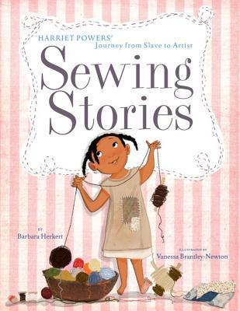

**Sewing Stories: Harriet Powers’ Journey from Slave to Artist** by Barbara Herkert

“Harriet Powers learned to sew and quilt as a young slave girl on a Georgia plantation. She lived through the Civil War and Reconstruction, and eventually owned a cotton farm with her family, all the while relying on her skills with the needle to clothe and feed her children. Later she began making pictorial quilts, using each square to illustrate Bible stories and local legends. She exhibited her quilts at local cotton fairs, and though she never traveled outside of Georgia, her quilts are now priceless examples of African American folk art.Barbara Herkert’s lyrical narrative and Vanessa Newton’s patchwork illustrations bring this important artist to life in a moving picture-book biography.”



**Crossing Ebenezer Creek** by Tonya Bolden

Freedom. Mariah has barely dared to dream of it her entire life. When General Sherman’s march through Georgia during the Civil War passes the plantation where she is enslaved, her life changes instantly. Joining the march for protection, Mariah heads into the unknown, wondering if she can ever feel safe, if she will ever be able to put the brutalities of slavery behind her.

On the march Mariah meets a young man named Caleb, and a new dream takes root—one of a future with a home of her own and a true love by her side. But hope often comes at a cost. As the treacherous march continues toward the churning waters of Ebenezer Creek, Mariah sees that the harsh realities of her and her peoples’ lives will always haunt them.

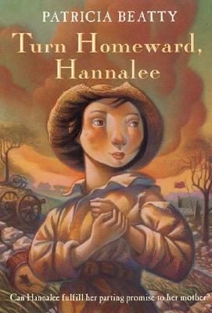

**Turn homeward, Hannalee** by Patricia Beatty

Twelve-year-old Hannalee Reed, forced to relocate in Indiana along with other Georgia millworkers during the Civil War, leaves her mother with a promise to return home as soon as the war ends.



**Kira-Kira** by Cynthia Kadohata

kira-kira (kee ra kee ra): glittering; shining Glittering. That's how Katie Takeshima's sister, Lynn, makes everything seem. The sky is kira-kira because its color is deep but see-through at the same time. The sea is kira-kira for the same reason and so are people's eyes. When Katie and her family move from a Japanese community in Iowa to the Deep South of Georgia, it's Lynn who explains to her why people stop on the street to stare, and it's Lynn who, with her special way of viewing the world, teaches Katie to look beyond tomorrow, but when Lynn becomes desperately ill, and the whole family begins to fall apart, it is up to Katie to find a way to remind them all that there is always something glittering -- kira-kira -- in the future.

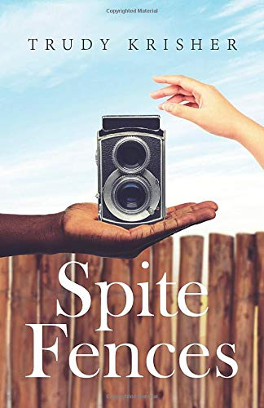

**Spite fences** by Trudy Krisher

Thirteen-year-old Maggie Pugh has lived in Kinship, Georgia, all her life. In all that time almost nothing has changed. If you are poor, you live on the west side of town. If you are rich, you live on the hill in the north end and get to go boating at the country club in Troy. If you are white you use one bathroom at Byer’s Drugs and if you are "colored" you use another.

All that starts to change in the summer of 1960. It is the summer when Maggie’s younger sister, Gardenia, triumphs in the Hayes County Little Miss Contest. It is the summer when Maggie must decide whether or not to tell anyone about the horrible thing she saw.

Most of all it’s the summer of Maggie’s first camera, a tool that becomes a way for her to find independence and a different kind of truth.



**Cold Rock River** by J.L. Miles

In 1963 rural Georgia, pregnant 17-year-old Adie Jenkins discovers the diary of pregnant 17-year-old Tempe Jordan, a slave girl, begun as the Civil War was winding down. The depth of the connection between the two women united by place and separated by race--and a century--is revealed.

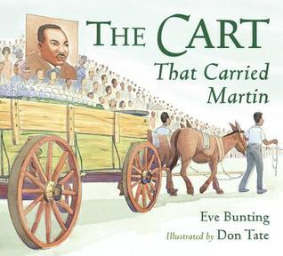

**The Cart That Carried Martin** by Eve Bunting

A unique retelling of Martin Luther King Jr.s funeral, focusing on the cart used to transport his coffin through the streets of Atlanta, Georgia, from Ebenezer Baptist Church to Morehouse College. The text also features the large number of people who walked the funeral route and were buoyed by MLKs positive influence, as well as Ada and Belle, the mules that pulled the cart.

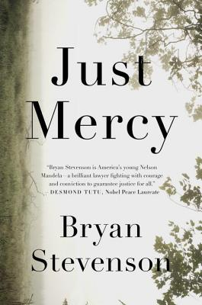

**Just Mercy: A Story of Justice and Redemption** by Bryan Stevenson

Bryan Stevenson was a young lawyer when he founded the Equal Justice Initiative, a nonprofit law office in Montgomery, Alabama, dedicated to defending the poor, the incarcerated, and the wrongly condemned.

Just Mercy tells the story of EJI, from the early days with a small staff facing the nation’s highest death sentencing and execution rates, through a successful campaign to challenge the cruel practice of sentencing children to die in prison, to revolutionary projects designed to confront Americans with our history of racial injustice.

One of EJI’s first clients was Walter McMillian, a young Black man who was sentenced to die for the murder of a young white woman that he didn’t commit. The case exemplifies how the death penalty in America is a direct descendant of lynching — a system that treats the rich and guilty better than the poor and innocent.



**Dear Martin** by Nic Stone

Justyce McAllister is top of his class and set for the Ivy League—but none of that matters to the police officer who just put him in handcuffs. And despite leaving his rough neighborhood behind, he can't escape the scorn of his former peers or the ridicule of his new classmates. Justyce looks to the teachings of Dr. Martin Luther King Jr. for answers. But do they hold up anymore? He starts a journal to Dr. King to find out.

Then comes the day Justyce goes driving with his best friend, Manny, windows rolled down, music turned up—way up, sparking the fury of a white off-duty cop beside them. Words fly. Shots are fired. Justyce and Manny are caught in the crosshairs. In the media fallout, it's Justyce who is under attack.